ICS 103: Computer Programming in C
Handout-14 Topic: 1-D Array (Sorting & Searching in 1-D Array).

Objective:

- Teach the Selection Sort, Linear search & Binary Search algorithms for 1-D Array.

What is Sorting?

- Sorting is the re-arrangement of a collection of data according to some key-field.
- We shall consider Selection Sort of sorting methods in this Lecture.

Selection Sort Algorithm:

This includes the following steps:

- Find the smallest (or largest) item in the list.

Place this item at the beginning of the list.

Repeat steps 1 and 2 starting at the beginning of the remaining list ( i. e for the other passes).

Notes:

Selection Sort has the advantage of simplicity and is adequate for small list of few hundred records.

The problem with selection sort is that the main loop executes n (number of records) times. More over, in each iteration it has to search the rest of the records for a minimum – about n comparisons. Thus it needs approximately n*n steps. For this reason, it is sometimes called a quadratic sorting method.

Another problem with selection sort is that it always scans the whole list looking for smallest even if the data happen to be in order.

Algorithm for Selection Sort:

#include<stdio.h>
void selection_sort(int x[], int size)
{
int k,pass,minpos,temp;
for (k=0;k<size-1; k++)
{
minpos=k;
for(pass=k+1; pass<=size-1; pass++) {
if(x[pass]<x[minpos])
minpos=pass;
}
temp=x[minpos];
x[minpos]=x[k];
x[k]=temp;
}
} // End of function

int main()
{

int y[]={4,2,9,1,5};
int k , size=5;
selection_sort(y, size); // Function call
printf("The sorted array is :\n");
for(k=0; k<size; k++)
printf("%d\n",y[k]);
return (0);
} // End of main

What is searching?

- Searching means scanning though a list of items or records to find a particular one exists.

- It usually requires the user to specify the target item or target key.

- If the target item is found, the record or its location is returned, otherwise, an appropriate message or flag is returned.

- Basic searching algorithms are: Linear search (or Sequential Search) and Binary Search.

- Linear Search can be used for sorted and unsorted data both.

- Binary Search can be used only for sorted data. If we have sorted list of data use of binary search is more efficient in comparison to linear search.

Linear Search:

- This involves searching through the list sequentially until the target item is found or the list is exhausted.

- If the target is found, its location is returned, otherwise a flag such as
–1 is returned.

Algorithm for Linear Search:

Let given a sorted or unsorted array, determine whether a given value or item or data is present in the array or not:

int lin_search (int list[], int size, int target)
{
int loc;
for (loc=0;loc<size ;loc++) {
if(list[loc]==target)
return loc;
}
return -1;
}

Solved Problem#2: (For Linear Search)

#include<stdio.h>
#include<conio.h>
int lin_search (int list[], int size, int target)
{
int loc;
for (loc=0;loc<size ;loc++) {
if(list[loc]==target)
return loc;
}
return -1;
}// end of lin_search function

void main( )
{
int size, key, LOC, i;
int list[10];
clrscr(); // it is used to clear screen
printf("Enter size of list(array) : ");

scanf("%d", &size);
printf ("Enter % d elements of the list from key board : \n", size);
printf("-------------------------------------------------------------------\n");

for(i=0; i<size; i++)
{
scanf("%d", &list[i]); // to read array from key board
}
printf("-------------------------------------------------------------------\n");
printf("Please Input target or key value which you want to search in list :");
scanf("%d", &key);

LOC = lin_search(list, size, key); // Function call

if(LOC !=-1)
{
printf("\nThe location of target %d in list of array is : %d\n ", key,LOC);
printf("\n\n\t(Dear, Remember position of first array value counted from 0)");
}
else
printf("\nDear Sorry , target %d not found in list of array", key);

return ;
} // end of main

Sample Output:

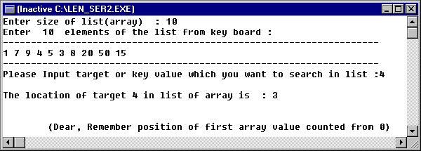

Binary Search:

For a list of n elements, the linear search takes an average of n/2 comparisons to find an item, with the best case being 1 comparison and the worst case being n comparisons.

However, if the list is ordered, it is a waste of time to look for an item using linear search (it would be like looking for a word in a dictionary sequentially). In this case we apply binary search, which will be more efficient.

Binary search works by comparing the target with the item at the middle of the list. This leads to one of three results:

If the middle item is the target – we are done.

If the middle item is less than target in that case we apply the algorithm to the upper half of the list.

If the middle item is bigger than the target in that case we apply the algorithm to the lower half of the list.

This process is repeated until the item is found or the list is exhausted.

The following functions implements this approach using both iteration and recursion.

In this assuming that the array is sorted in increasing order:

Recursive Function for Binary Search:

int binarySearch ( int x[], int low, int high, int target)
{
int middle;
if (low > high) /*base case1:target not found*/
return –1;
middle = (low + high)/2;
if (x[middle] == target)
return (middle); /*base case2:target found*/
else if (x[middle] < target)
return(bin_search(x, middle+1,high,target)
else
return(bin_search(x, low, middle-1,target)
}
Explanation for Binary Search :

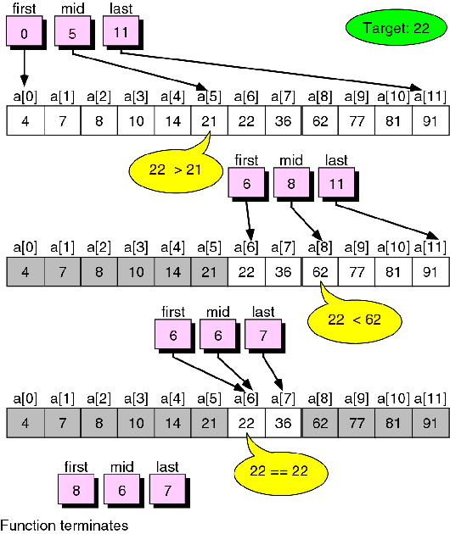

NOTE: In this diagram first is used in place of low, last is used in place of high.

Solved Problem#3: (For Binary Search)

#include <stdio.h>
#define MAX_ARY_SIZE 12
int binarySearch (int x[], int low,int high, int target); //function prototype

int main ()
{
int i ,locn, target;
int ary[MAX_ARY_SIZE] = { 4, 7, 8, 10, 14, 21, 22, 36, 62, 77, 81, 91 };
printf("Data: ");
for (i = 0; i < MAX_ARY_SIZE; i++)
printf("%3d", ary[i]);
printf("\n\nEnter a key for search : ");
scanf("%d", &target);
do
{
locn= binarySearch (ary,0, MAX_ARY_SIZE - 1, target);
if(locn!=-1)
printf("%3d found at location: %2d\n", target, locn);
else
printf("%3d NOT found in array\n", target);
printf("Enter next key or -1 to quit: ");
scanf("%d", &target);
} while (target != -1);

printf("\n\nEnd of search.\n");
return 0;
} /* end of main */

int binarySearch( int x[], int low, int high, int target)
{
int middle;
if (low > high) /*base case1:target not found*/
return -1;
middle = (low + high)/2;
if (x[middle] == target)
return (middle); /*base case2:target found*/
else if (x[middle] < target)
return binarySearch(x, middle+1,high,target);
else
return binarySearch(x, low, middle-1,target);
}

